**READ ME**

CG ASSIGNMENT 3

**CAMERA MODES**

* STATIONARY MODE: This is the mode which shows the camera moving along the walls. The direction keys can be used to move the camera along the walls.
* THIRD –PERSON MODE: This mode shows the scene from behind the dog. The dog can be rotated using ‘A’ and ‘D’ and the camera can be rotated using the direction keys(left & right).

**ABOUT THE DOG AND SURROUNDINGS**

Fluffy and Luffy have been trapped in a room in outer space. While Luffy prefers to stay still at a place, Fluffy is rather active and can both **WALK** and **RUN**. So, we will take control of Fluffy. Apart from the dogs, the room also contains a moving fan, a levitating rotating cube and a textured teapot (I don’t know where it came from.) Bounds checking is done for the walls. Please avoid running into other objects or Luffy. Fluffy can move anywhere in the room.

Textures have been used in many places, for walls,roof,floor and teapot.

**CONTROLS**

|  |  |
| --- | --- |
| **KEY** | **FUNCTION** |
| F | Forward |
| B | Backward |
| C | Toggle Camera Mode |
| Direction Keys | Camera Move |
| A | Rotate Animal Left |
| D | Rotate Animal Right |
| T | Toggle Run/Walk |
| R | Reset to initial state |
| W | Toggle Wireframe |
| Q | Quit |

**SOFTWARE USED**

We used Microsoft Visual Studio 2010 along with Glut and Opengl to make this project on Windows Platform.

**IMPORTANT**

The user is requested to explore both camera modes

(Press C) in both walking and running modes (Press T) and rotate the camera using direction keys. It is advised to view wireframe in third person view for a better detail.

**WARNING**

The emulation speed may differ from computer to computer due to varying specs. The movement can be a little slow in some PCs.

**SCREENSHOTS**

Rooftop View

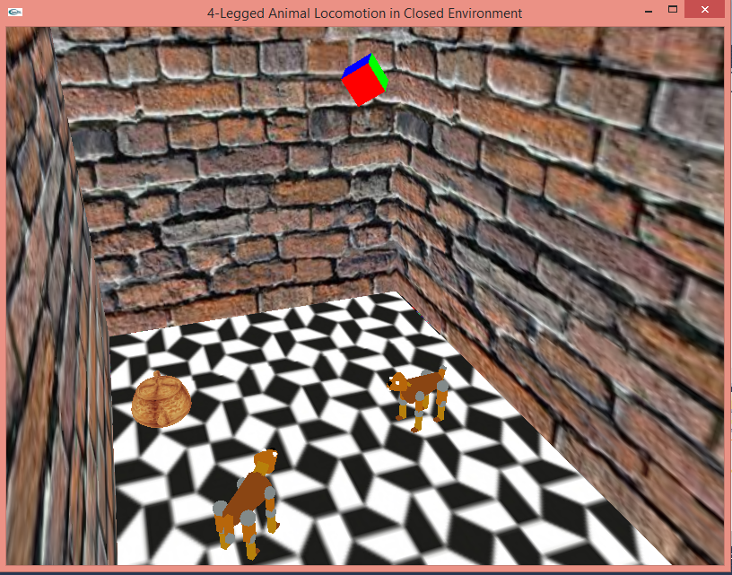

Space View

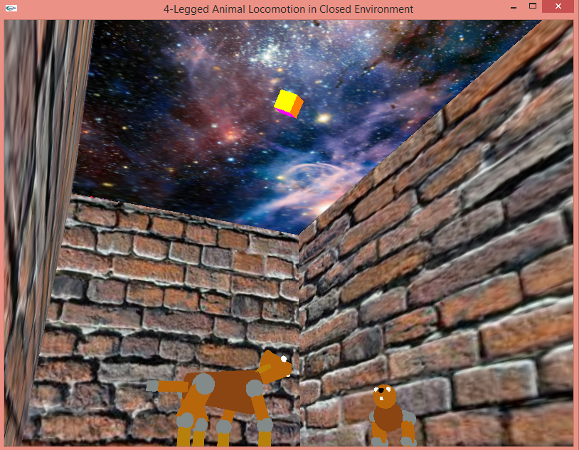

Third Person View

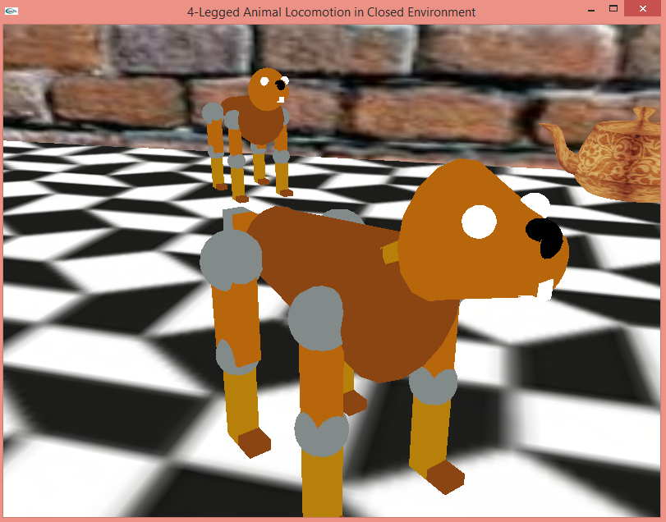

Wireframe in Third Person View

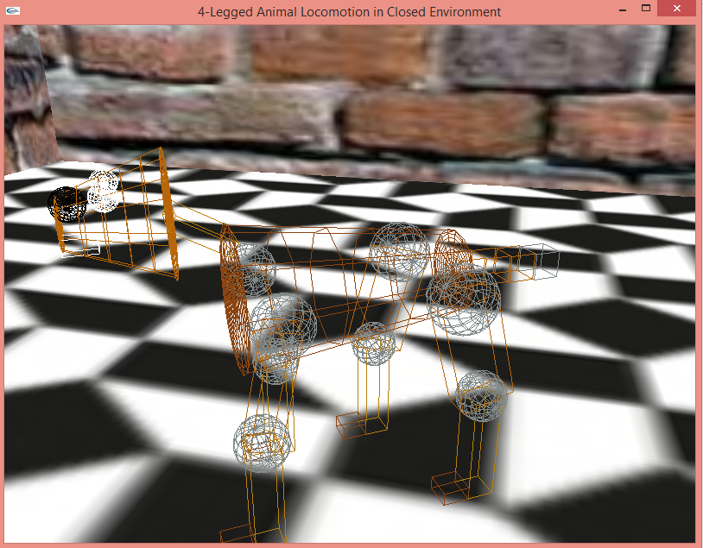

Textured Teapot

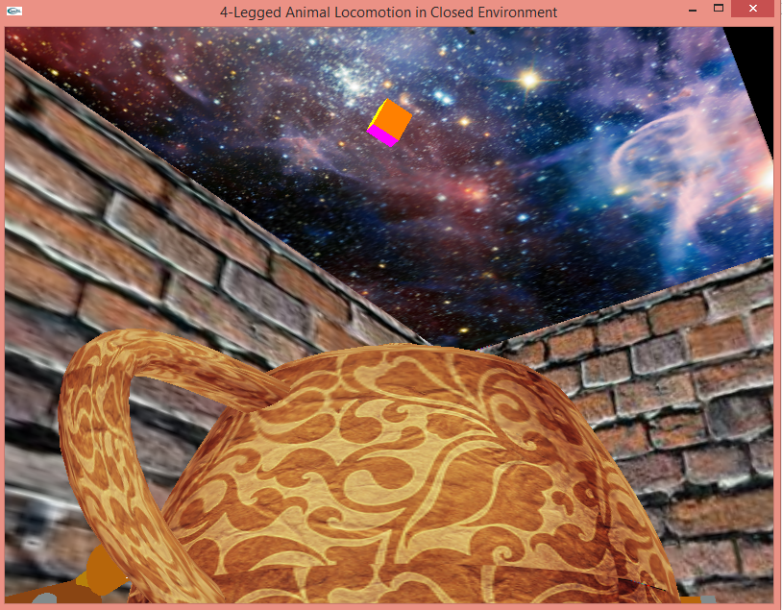

**SUBMITTED BY :-**

* Sanjog Yadav 2014A7PS041P
* Abhinav Tiwari 2014A7PS049P